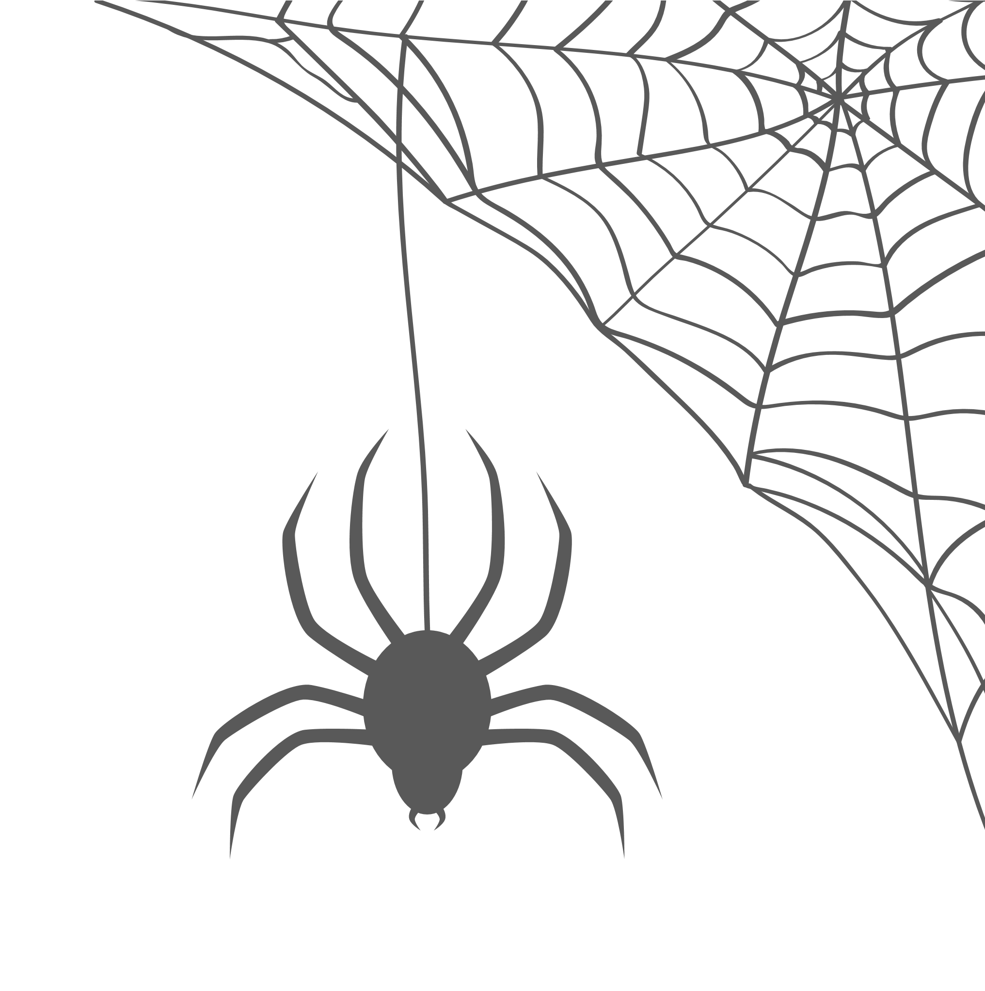

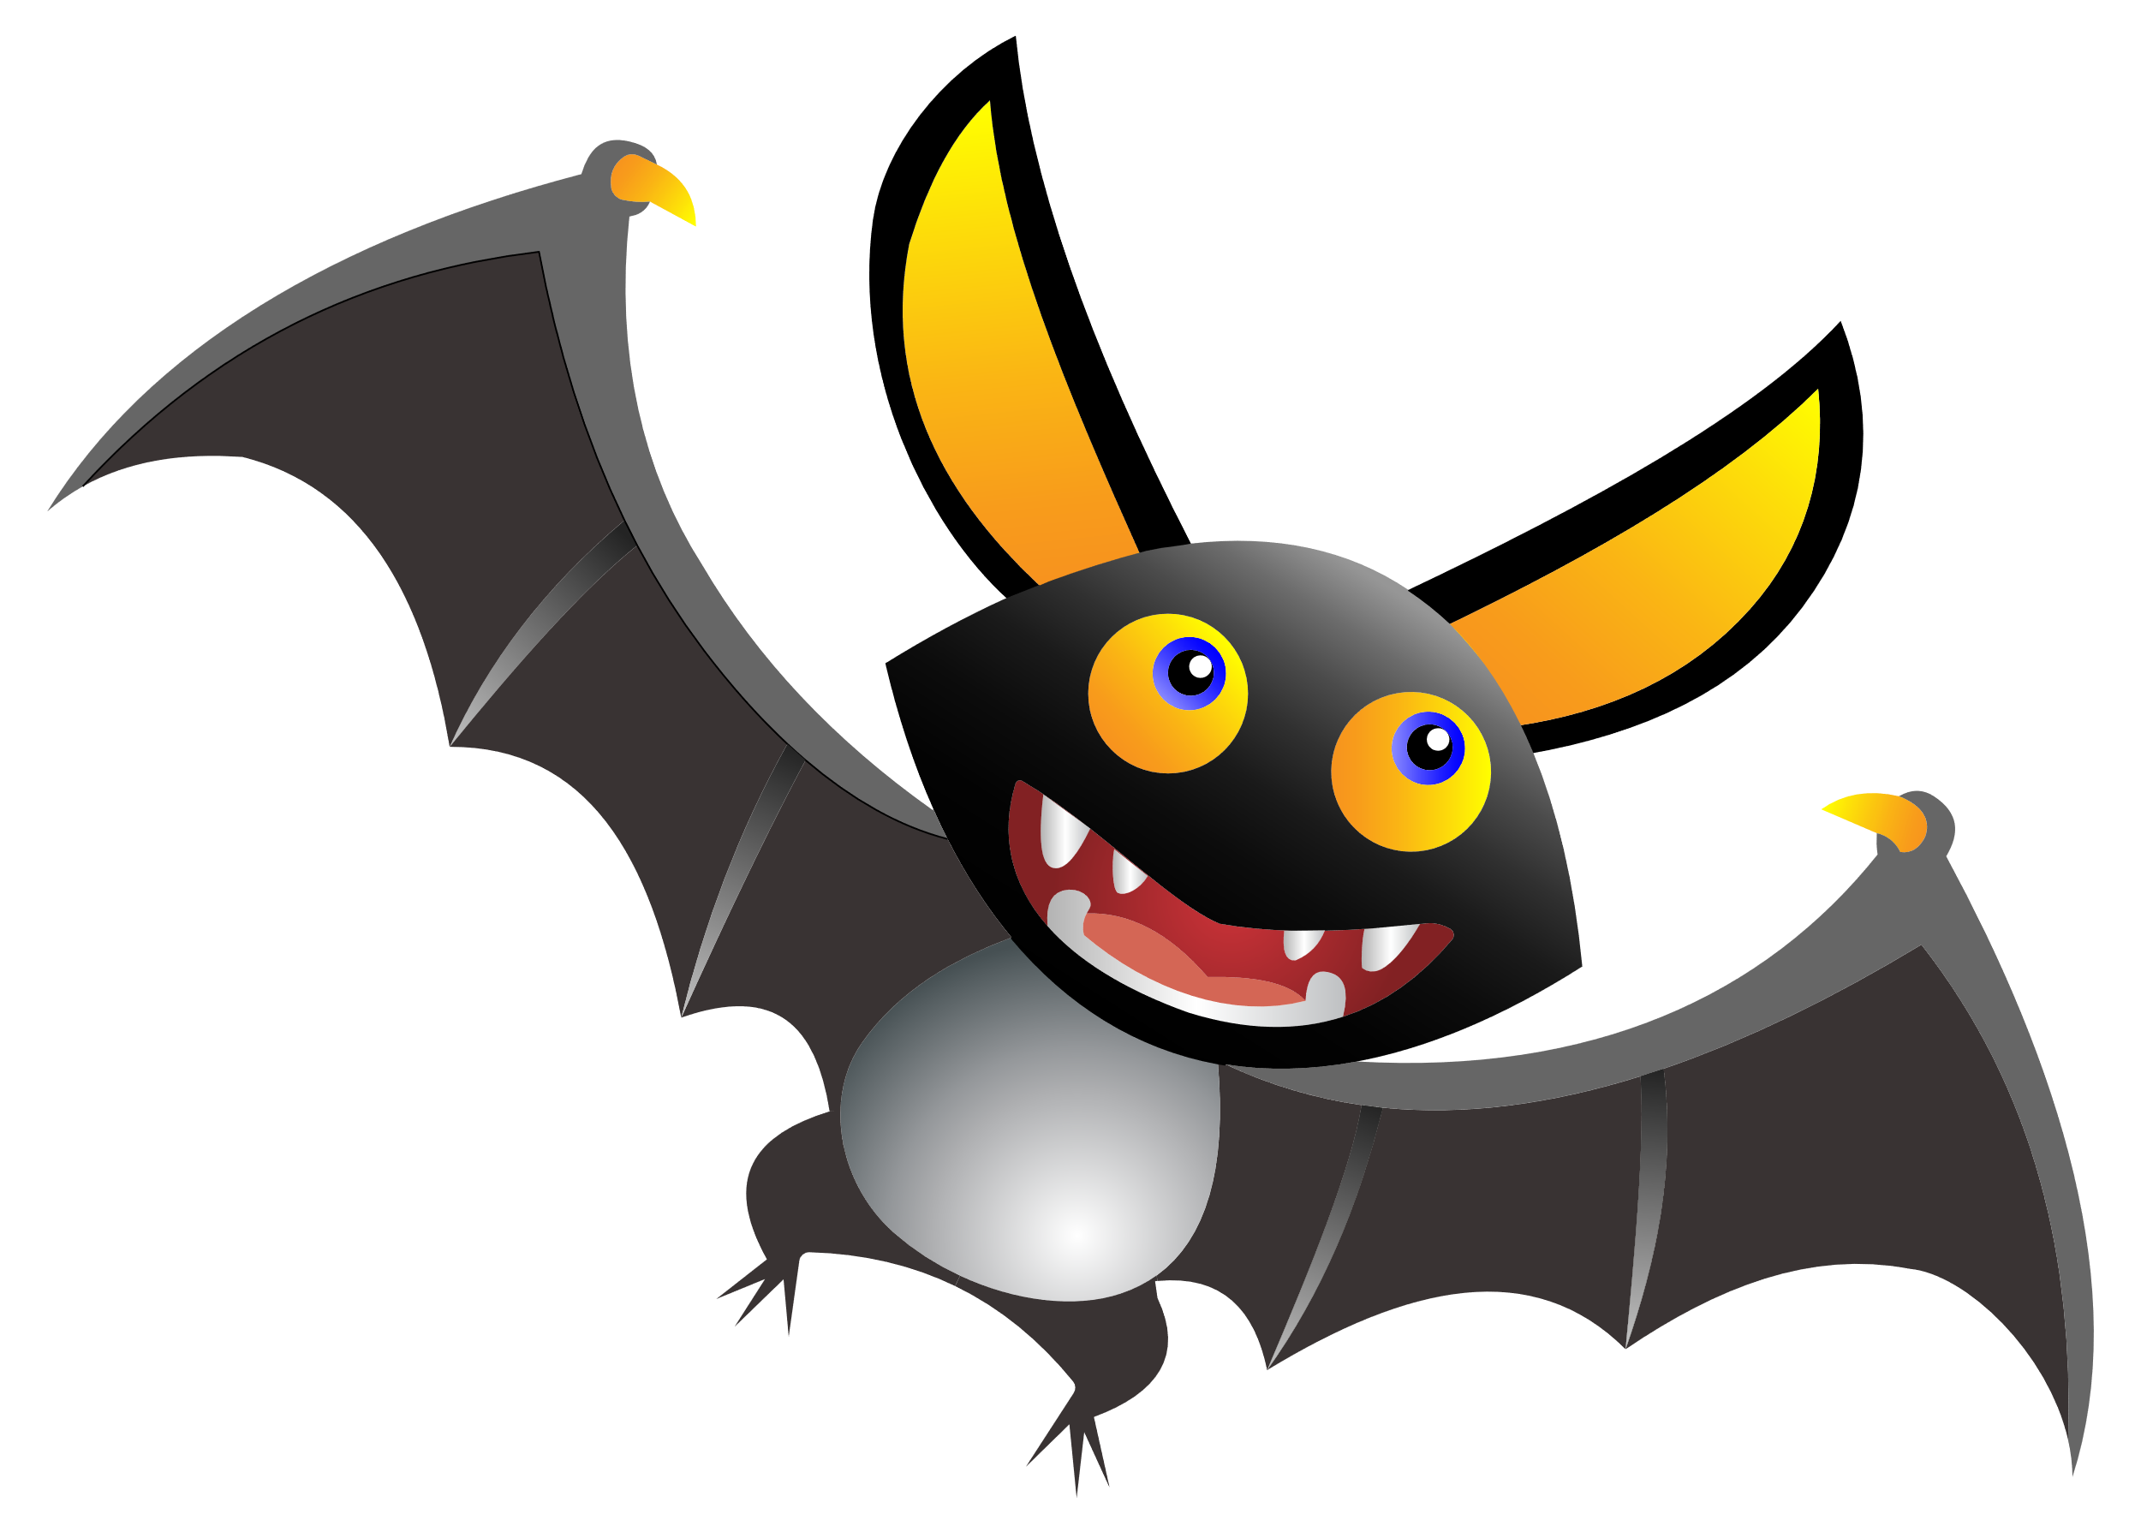
You’re Invited to a

HALLOWEEN

PARTY
October 28th, 9pm
Creepy Lair, Warlock Road
Costumes Required
RSVP: Mr Dracula

